How to connect a Windows 7 Computer to Champstudent
Purpose: To instruct Champlain College faculty, staff and students in the process of connecting a computer running Windows 7 to the wireless network champstudent.

- Open the Network and Sharing Center
  - In the system tray on the bottom-right of the screen near the clock, click on the escalating bars icon once.
  - Once the list is open, click Open Network and Sharing Center at the bottom.
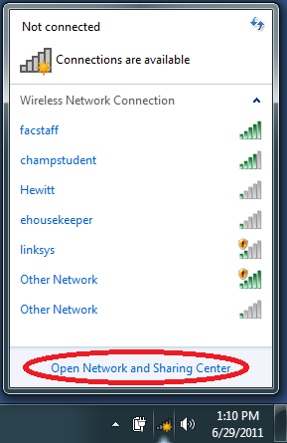

- Open the Manage Wireless Networks tool
  - In the left-hand navigation bar of the Network and Sharing Center, click the option that says Manage Wireless Networks.
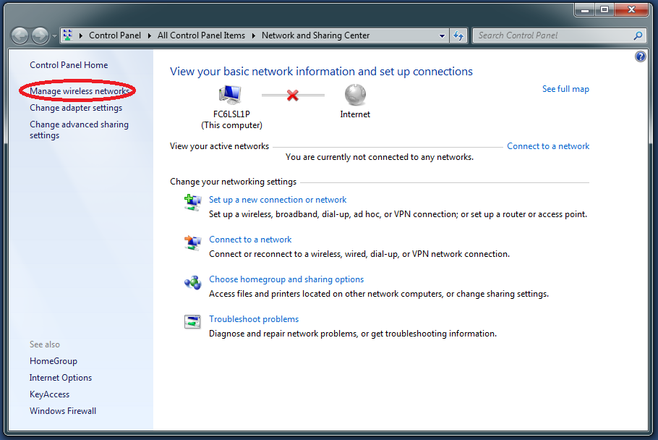

- Add a new wireless network manually
  - On the Manage Wireless Networks screen, you will see the option to Add in on the toolbar. Click this.
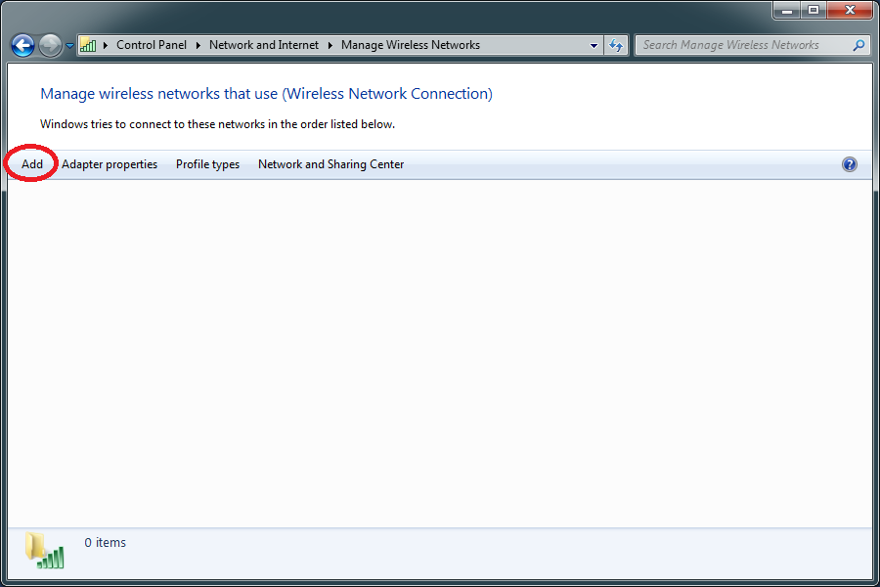

  - When prompted, select the option to manually create a network profile.

- Enter the champstudent network information
  - Ensure that you enter the same information as shown in the screenshot below, including the list options and check boxes.
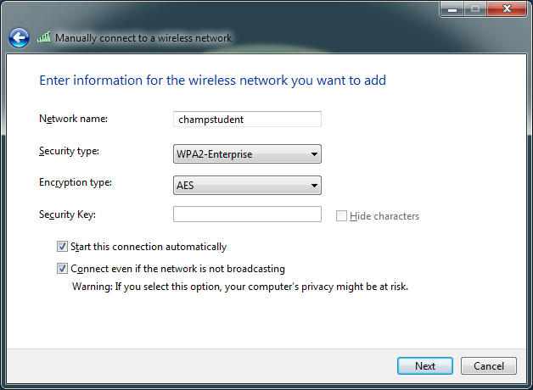

- After adding the network, immediately click the option to change connection settings
  - A dialogue box will appear after adding it that lets you change settings to the network. More settings must be configured before the connection will work, so select this option.
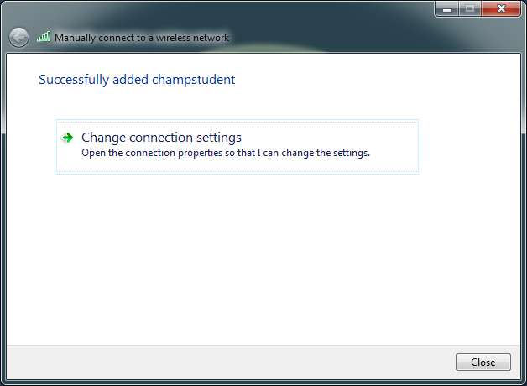
- Change the Security settings for the network
  - In the network properties, click the tab at the top labeled Security.
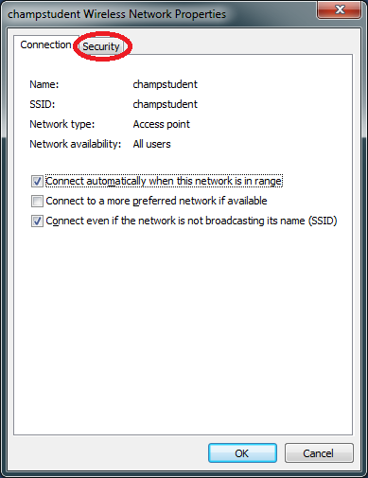

  - To begin, click the Settings button under the network authentication section.
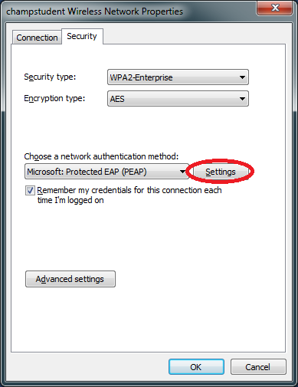

  - Uncheck the option to validate the server certificate, and uncheck Enable Fast Reconnect. After doing this, click the Configure button under Authentication Method.
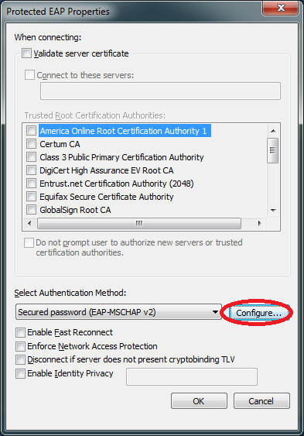

  - Uncheck the option to use your Windows logon name and password, and then click OK. After the window closes, you can also click OK on the Protected EAP Properties window that you were at before that one.
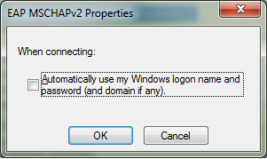

  - Once you’re back at the Security properties, click the advanced settings button.
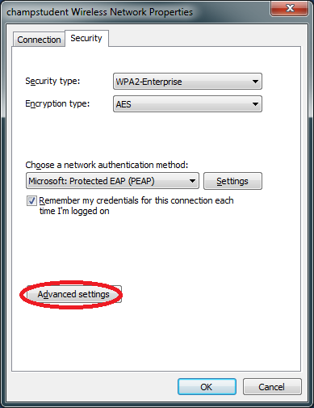

  - Check the box to specify authentication mode, and select User authentication. Then click save credentials to enter your Champlain identity information.
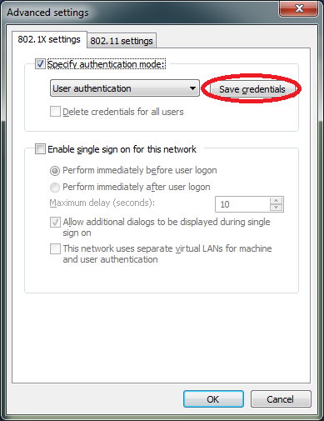
  - Once you’ve entered your login information, you can click OK on all of the open windows, as configuration is now complete.
Revision | Author | Reason for revision | Date
A | Jack Donovan | Created this document | 23JUN11

