Legal Studies Links

Legal Studies Job Boards paid
membership?

LawJobs.com – A comprehensive resource for legal jobs in most major cities. Includes postings for administrative, legal secretary, paralegal, and attorney positions.
USA Jobs - The U.S. Government's official site for jobs and employment information.
LawCrossing – LawCrossing tracks down legal jobs from all over and pulls them $$$
together in one place. It’s primarily geared toward attorneys but also posts
paralegal and legal secretary positions.
The Affiliates - The world's leader in specialized legal support staffing. $$$
American Federal Jobs Digest - Over 10,000 current Federal employment $$$
and career jobs database.
EmpLAWYERnet.com - Law Employment connections site. $$$

Legal Studies Professional Associations

The Association for Legal Career Professionals (NALP) – NALP is dedicated to continuously improving career counseling and planning, recruitment and retention, and the professional development of law students, lawyers, and its members.

NALS …The Association for Legal Professionals – It’s a name, not an acronym. NALS welcomes Paralegals, Legal Assistants, and Legal Secretaries. They provide continuing legal education, certifications and networking to all members of the legal community.
National Federation of Paralegal Associations (NFPA) - Founded in 1974, NFPA was the first national paralegal association. It is comprised of more than 50 member associations and represents over 9,000 individual members reflecting a broad range of experience, education and diversity.
National Association of Legal Assistants (NALA) - NALA is the nation's leading professional association for paralegals. As a non-profit organization, NALA provides continuing education and professional development programs for paralegals - from novice to experienced professionals.
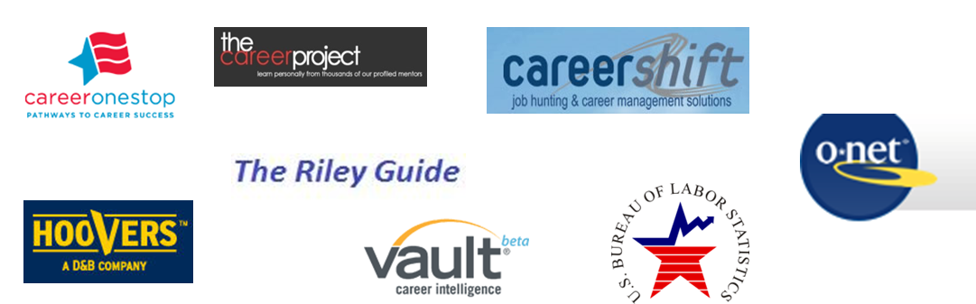
links to General Career InformatioN

