Revision | Author | Reason for revision | Date
A | Jack Donovan | Created the document | 10/19/10
B

Purpose: To instruct how to set up a connection with the campus ChampStudent network using Mint or any similar GNOME distro.

Procedure:

- Open the Edit Connections window by right-clicking the network icon in your taskbar and selecting Edit Connections.

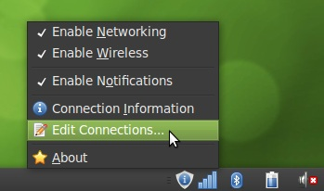

- Add a new Wireless connection. Make sure it’s in Infrastructure mode, and set the SSID as champstudent.

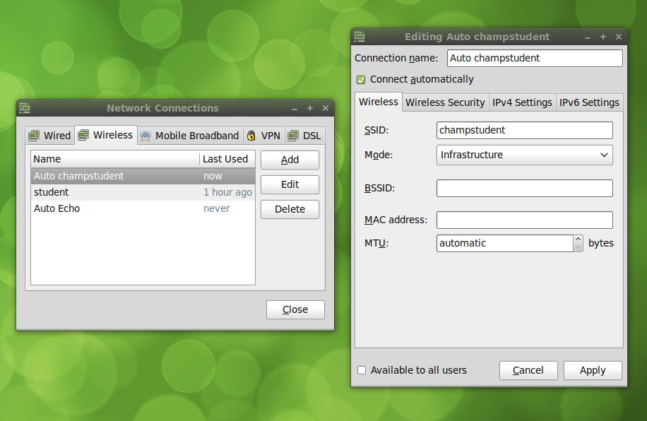

- Set it to Connect automatically. Make sure the Security is set to WPA & WPA2 Enterprise, the Authentication is set to Protected EAP (PEAP), and the Inner authentication is set to MSCHAPv2. The PEAP version should be Automatic.

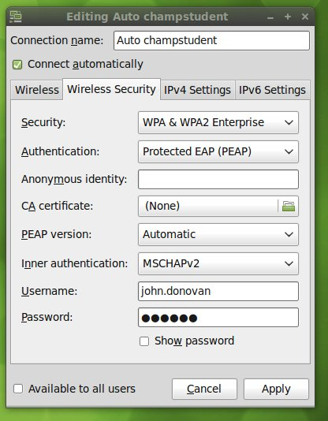

- Type your Champlain credentials in their respective fields and click Apply. Your computer will now connect to the internet.

